THE RELATIONAL CIRCUIT REVISITED

Paul Ryan
Media Studies, New School University, NYC
255 West 105th Street #42, NYC, NY 10025
waterpr3@aol.com
© This paper may not be reproduced without the permission of the author.

ABSTRACT
The author revisits the relational circuit, an original topological figure that synthesizes cybernetics and semiotics. This circuit was first presented to the semiotic community in a 1991 essay entitled ‘A Sign of itself’. Technical issues discussed include the difference between a torus and the relational circuit as well as the possibility of difference without discontinuity. Issues of meaning discussed include the possibility of using the feedback made possible by the relational circuit for conflict resolution in the context of our current war on terror.

1. INTRODUCTION
The French thinker, Gilles Deleuze, describes creating a concept as a process of giving shape to a scream. The need to scream opens up an opportunity to shape a concept that transforms the scream (Lambert 2002: 36). The relational circuit is a concept that arose out of my personal scream. My personal scream was articulated- as a scream- in a video wake I performed for my father in May of 1971. Upon his sudden death I replayed a videotape of him while he was alive as I wailed into a video camera for twelve uninterrupted hours. I then invited over a hundred people to see the tape in my apartment. I was not there. In 1976, I enacted a three-hour version of the video wake live at the Kitchen Performance Space in New York City (Ryan 1974, 1976, 1996).
The content of the video wake ranges widely, yet most of what I say has to do with relationships. I rave about the relationship between my father and his father, ruptured by the gassing of my grandfather during WWI. I rave about the relationship between women and myself, particularly a woman who betrayed me on the night my father died. I rave about the relationship between our species and its ecosystems, a situation I had become alarmed about through an encounter with Gregory Bateson, author of Steps to an Ecology of Mind.
Screams die out. Concepts endure. If a concept is healthy, its wise use will enable others to avoid the repetition of needless screaming. To create a healthy concept, I used criteria put forth by Gregory Bateson, criteria I prodded him to articulate (Metalogue: Gregory Bateson, Paul Ryan in Ryan, 1980, 1993: 174-196). In my 1991 essay ‘a Sign of itself’, I described how my relational circuit satisfies Bateson’s criteria and simultaneously satisfies philosopher Charles Peirce’s quest for ‘a Sign of itself’. This combination means that Peirce’s entire phenomenological and semiotic system becomes cyberneticly operative. My prime example of this possibility is a design for an environmental television channel dedicated to monitoring the ecology of a region for the people that live there so they do not destroy their supporting ecosystem (Ryan 1993: 243 ff.). In other writings, I discuss other possible uses of this concept in education (1993, 2001), worker training (1998), and gender relationships (2002).
At the invitation of Peter Harries-Jones, the editor of SEED, this article revisits the 1991 ‘Sign of itself’ essay in the context of the emerging dialogue about representations of a ‘topology of meaning’ and meaning. More specifically, the editor asked me to differentiate between the relational circuit and a torus and suggested I discuss discontinuity and differentiation. Before engaging these technical issues, let me address one particularly salient issue I wailed about in the video wake for my father, the issue of war.
Currently, we are involved in a war on terror. Why? Because U.S. citizens, civilian and military alike, have been named the evil enemy in a religious war between good and evil by people willing to choose martyrdom. In response, President George W. Bush calls these same people, Osama bin Laden and his networks, ‘the evil doers’. The whole world is cleft in two. Once again, it’s us against them.
The dualistic assumptions that often result in war have also bedeviled philosophy. To resolve the problem of dualism on a philosophic level, Charles Peirce, gave us three irreducible categories that deal with everything. He called them firstness, secondness and thirdness. Briefly, firstness has to do with the quality of a thing or the feeling that is part of an experience, secondness with fact and reaction, and thirdness with pattern and mediation. Mediation means conflict resolution. Mediation means making peace. As we will see, the relational circuit offers a formal, unambiguous way of working with Peirce’s categories to make peace.
In the year 2004, global electronic communication has become virtually instantaneous. Suddenly, everybody has their nose in everybody else’s business, as if we were living in a village. To describe this emerging condition during the 1960’s, media guru, Marshall McLuhan, coined the term ‘Global Village’ (1964). In the global village, people with differences of nationality, race, religion, and culture rub up against each other, both live and electronically, without the time or means to find healthy ways of relating. Without healthy patterns of connection between people, situations easily degenerate. Relationships go awry.
As humans, we care immensely about our relationships to other human beings. Is this relationship trustworthy? Does this person care for me? Does this ethnic group respect my ethnicity? We understand our relationships by paying close attention to the feedback we get from others. What did she mean by that remark? Will he leave me for another? Why won’t he talk to me? Am I being dealt with as a stereotype? Failure to provide meaningful feedback to others leaves them without a way to navigate the shared relationship.
McLuhan saw violence as a ‘lust for compensatory feedback’. When people don’t get the feedback necessary to adjust their relationships, he asserted, they will lash out in order to teach others not to ignore them. The absence of feedback causes violence. In place of the missing feedback, necessary to adjust and navigate the challenges of a particular relationship, violence makes a public announcement of the failure to relate.
My guess is that McLuhan would have interpreted the violence of September 11, 2001 as generated by a lust for compensatory feedback. Unilateral behavior by the global superpower, perceived as unjust, leaves many others without the feedback necessary to adjust and maintain the integrity of their cultures in the emerging world. In this sense, the unappeased accumulation of desire for recognition and redress of grievances is what piloted the planes of destruction.
If the absence of feedback can create war and confusion, the fullness of feedback can create peace and tranquility. Creating feedback requires the proper circuitry. Drawing on Gregory Bateson’s understanding of circuitry and human relationships, I have created the relational circuit, more or less explicitly for human relationships. As we will see, this relational circuit uses Charles Peirce’s three categories to make possible a fullness of feedback among three or more people. I will end this article with a brief scenario of how this fullness of feedback could support conflict resolution.

2. THE RELATIONAL CIRCUIT
Now for the technical discussion of the relational circuit itself. I will draw extensively on the 1991 “Sign of itself’ essay. The relational circuit is a topological figure presented below (Figure 1).
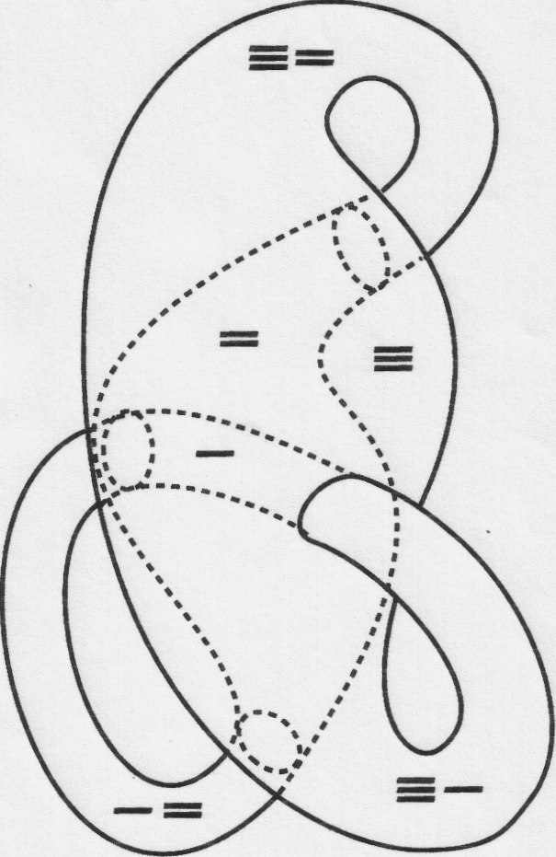
Figure 1: The Relational Circuit (a six part closed Kleinform) with its six unambiguous positions labeled. e is a position of firstness ( ), a position of secondness (=_), and a position of thirdness ( ). In addition, there are three in between positions
Based on a process which Peirce calls ‘abstractive observation’ eighteen characteristics can be attributed to the relational circuit. (Peirce 1931—35: 2.231).
- 1). One
- There is but a single circuit.
- 2). Empty
- The circuit is empty. The emptiness itself constitutes the circuit.
- 3) Continuous
- The circuit is a continuum. It is possible to move from within any part of the circuit to any other part without crossing a boundary.
- 4). Bounded
- The circuit is bounded. The boundary limits the continuum.
- 5). Infinite
- The continuum of the circuit is infinite. The continuum returns to itself without end.
- 6). Six-Part
- The circuit penetrates itself six times. This self-penetration yields six different positions on the continuum. Each position is part of the continuum.
- 7). Positional

- The differentiation in the circuit is structured according to differentiation of position on a continuum. In contrast to any statement of description, differentiation in the circuit does not correspond to the differentiation implicit in the subject/predicate structure of propositions. Hence, the circuit cannot be fully explained in any axiomatic system of propositions. The circuit is positional, not propositional.
- 8). Unambiguous
- The six positions are unambiguous. There is but one position of firstness, but one position of secondness, and but one position of thirdness. For refined observation, thirdness can be described as the position surrounding secondness in which a stiff torus can be trapped. All the other positions are differentiated by the passage of the continuum through the thresholds created by the self-penetration. There is only one position on the continuum between firstness and secondness, only one position on the continuum between secondness and thirdness, and only one position on the continuum between thirdness and firstness.
- The naming of these positions is not arbitrary, but follows Peirce’s definitions of firstness, secondness and thirdness (Peirce 1955). Firstness is a compact, empty position, free of any other. Secondness has another part of the circuit passing through it—something it is up against—the position of firstness. Thirdness contains both secondness and firstness.
- 9). Non-Identical
- No position in the circuit is identical with any other position. No two positions can be equated.
- 10). Non-Orientable
- Assigned direction makes no difference in determining the relative positions in the circuit. This can be understood by contrasting non-orientation with the orientation involved in reading. As a reader, your eyes are moving from left to right, down the page of print that is in front of you. If you turn 180 degrees, what was in front of you is now behind you, what was on your left is now on your right. In this conventional understanding of position, if you change your orientation, you change your referencing system for position. In the circuit, changes in orientation make no difference in determining relative positions. The circuit has no center, no front and back, no left and right, and no up and down. The six-part differentiation of position holds regardless of orientation.
- 11). Intransitive
- It is possible to understand each position in the continuum without going outside the bounds of the continuum. Each position, in turn, is explained by two other positions. The position of firstness is the position contained by secondness and thirdness. The position of secondness is contained by thirdness and contains firstness. Thirdness contains both secondness and firstness. Each of the “in between” positions on the handles is explained by reference to two of the three positions of firstness, secondness, and thirdness.
- 12). Complete
- The circuit is complete. The term “complete” is used here in two senses.
- i) Nothing outside the circuit is required to make it whole. By contrast, the series of natural numbers is always incomplete. One can always move toward completion by adding another number. Indeed, the sequence of natural numbers can be embedded in this six-part continuum in sets of six with remainders ad infinitum.
- ii) Nothing outside the circuit is required to understand its wholeness. The circuit consists of an empty continuum of six positions. Each position is explained in terms of the other positions in an intransitive way. The circuit has all the parts necessary to explain itself. No meta-level of explanation is required.
- 13). Consistent
- The circuit is one continuum with six positions. There is no position which is also not a position. There is no position which is simultaneously another position, as in the case when two people face each other and what is on one person's right side is simultaneously on the other person's left side. Although secondness simultaneously contains and is contained, the reference for each relationship is unambiguous. The circuit is internally consistent.
- 14). Relative
- The circuit is absolutely relative. The six positions are completely determined by each other. To move from one position to another position is to change relationship to every other position. A difference in position makes a difference in relationship.
- 15). Non-Sequential
- While it is possible to move sequentially through all six positions, the positions themselves do not depend on sequence for their identity. The positions of firstness (F), secondness (S) and thirdness (T) are indifferent to sequence. You can outline the circuit on the floor and move through the continuum in any of the following sequences without altering the positions themselves. (For simplicity of explanation, I am omitting the in-between positions.) FST, TSF, STF, SFT, TFS, FTS. In the last example, FTS, what is indicated is that you can go from firstness to thirdness without passing through secondness. Firstness and thirdness are contiguous without reference to secondness. Relative position is detached from sequence.
- 16). Irreducible
- The circuit cannot be reduced and maintain its characteristics. For example, the only possible reduction of the figure that remains bounded would be a four-part circuit with one part containing another part and two parts uncontained or two ‘handles’. However, in such a reduction the two parts uncontained could not be distinguished from one another without going outside the circuit and referencing the left and right hand side of the viewer. Such outside referencing would violate the non-orientable characteristic of the circuit.
- 17). Non-compact
- The figure cannot be reduced to a ball and retain its identifying characteristics. Like the “hole” is integral to the identity of the torus, the three “holes in the handles” are integral to the identity of this circuit.
- 18). Heterarchic
- Choices between positions within the circuit operate according to intransitive preference. That is to say, choices are not constrained by a hierarchy but can operate heterarchically. If I outline the circuit on the floor and stand in the position of firstness, I can move through an “in-between” position (— = ) to the position of secondness (=). But once in secondness I am not compelled to move to thirdness, as if there was a fixed hierarchy of preference or choice. I can return to firstness (-). Any position in the circuit allows this pattern of intransitive preference. There are always two choices, and no choice compels an irreversible sequence of hierarchic choice.

3. SURFACELAND AND CIRCUITLAND
Since publishing a ‘Sign of itself’, it has become apparent that a few readers perceive the relational circuit as ‘merely’ a torus that penetrates itself. This perceptual judgement is based on what I would call surfaceland perception. During the time I developed Kleinforms and the relational circuit (1968-1976) I was consciously trying to build bridges of understanding between the print world of paper surfaces and the electronic world of video circuits (McLuhan 1962, 1964). In part, I see misperception of the relational circuit as a result of the problems of the disjunct between surfaceland and circuitland, problems reminiscent of Edwin Abbott’s depiction of the disjuncture between flatland and spaceland. (Abbott 1952). To see the relational circuit only in terms of a torus is to allow your perceptions to be constrained by surface topology. Surfaceland, extensively mapped by surface topology, is constituted in perspective space. By contrast, the relational circuit is part of a circuitland that invites participatory perception from recursive positions. As the poet Charles Olson has it: “mappe mundi/myself included”. To indicate how this recursivity works, I have provided an appendix with instructions for a personal video feedback process that the reader can use to re-create the circuit for herself.
Following Bernhard Riemann, as I understand him from reading Peirce scholarship, I think of topology as the study of relations of position and inclusion independent of measurement (Murphey 1961: 194-237). My understanding of topology is pre-axiomatic, based as much on my experience as an artist as on my readings. ‘Position’ I take to mean a place or locus relative to other places or loci. ‘Inclusion’ I take to mean containing in some sense. I think of the relational circuit not as a surface on which to map positions but as a tube that constitutes positions. What I would call tubular topology designates position in terms of the empty space within tubes, not in terms of surfaces. Hence the designations- ‘part contained’, ‘part containing’ and ‘part uncontained’- used in the exercise appended. Each phrase designates a different position in a tube relative to other positions. Formulating this threefold differentiation freed me from the constraints of surface topology and habits of orientation. (See figures 3, 4, and 5 in the appendix for examples of topological figures built from a tube. Also see Ryan 1971, 1974, 1993).
In 1971, I published my first iteration of topological figures built from a tube, which I would eventually call Kleinforms. These Kleinforms arose out of three years of experimentation with video feedback of the sort distilled in the exercise in the appendix. My experience with video feedback mapped onto a Moebius strip, not onto a mirror (See appendix, Ryan 1993: 36-42, Bateson 1979: 82-86). If you simulate shaking hands with yourself in a mirror, it will not work. The mirror will return a left hand to your right hand. If you face a video camera placed on top of a monitor and simulate a handshake, it will work. The monitor will return a right hand to your right hand. This was a critical distinction for me. Throughout the process of building the relational circuit, I held to this Moebius perception of myself.
At the time I first published the Kleinforms I called them Klein Worms. I sent six graphics of Klein Worms to topologist, Rene Thom (Ryan 1971). While I am not sure where the letter is, Thom wrote back saying that he did not really understand what I was doing but that what I had sent him seemed ‘highly original’. With this encouragement, I went on to expand the series of Kleinforms until I arrived at the relational circuit (Ryan 1974 1993). Other ingredients in the creative cauldron at the time included Bateson’s definition of information as a difference that makes a difference, Peirce’s three categories, McCulloch paper on heterarchy (McCulloch 1965: 40-45), video experimentation with three-person relationships (Ryan 1985), holography experiments, and the topologically rich paintings of French artist, Claude Ponsot.
Klein bottles belong to surfaceland. Kleinforms do not. While in surface topology the surface is not permitted to pass through itself, in tubular topology this rule does not hold. Kleinforms are not Klein bottles. In Kleinforms, at least as I invented and named them (Ryan 1971 1974 1993), self-penetration is permitted. It is this self-penetration that enables Kleinforms to map the duration of time that occurs in the process of video feedback, the process that led to formulating the Kleinforms. The continuity within the chamber of the tube is being rendered, not the connectivity possible on the surface of the tube.
In surface topology, an “orientable” surface is one having an inside and an outside. For example, the non-orientable surface of the Moebius strip has neither inside nor outside. This definition of orientation is particularized for surface topology. In surface topology this description of orientable as having an inside and outside is accurate enough, but in tubular topology it is misleading. In my understanding, as indicated in characteristic number 10 above, the more general definition of orientation has to do with directionality. Orientation means assigned direction. In the relational circuit the six positions obtain in relation to each other without any need to assign direction, i.e., no up or down, left or right, front or back.

In the genesis of the relational circuit I went from the Moebius strip to the Klein bottle to the Kleinforms to the relational circuit (Ryan 1993). This genesis may have involved what, in the art world, would be called a ‘creative misinterpretation’ of surface topology, specifically of the Klein bottle. It does seem worthwhile to re-examine the relational circuit based on the rigors of surface topology. It seems possible to ‘reverse engineer’ a relational circuit by slicing through a simple torus thus creating a tube, having that tube self penetrate six times in the manner of the relational circuit, and then fusing the ends of the tube together at the original slice. Re-constructing the relational circuit in this way could yield new insights. In surface topology it is permissible to ‘temporarily’ cut a shape as long as the cut is reconnected. In effect, my threefold differentiation of positions in the Klein bottle into part contained, part containing and part uncontained allowed me to work in that ‘temporary’ zone for years and develop the open Kleinforms. Open Kleinforms, while they have threefold differentiation of parts contained, containing and uncontained also require some orientation, i.e., you must assign which end to start with. My eventual closing of the tube in the shape of the non-orientable relational circuit, would, in surface topology, amount to a reconnecting of a self-penetrating torus at the ‘cut’.
The question of time and topology is beyond the scope of this paper, however, permit me a brief digression. In the original set of open kleinforms that I invented, one part could be anticipated by another (Ryan 1971:2, 1993: 98-101). A part to be contained could be laid out before actually being contained, as in the exercise appended. This explicit temporal dimension was relinquished in the final relational circuit. I was willing to relinquish this temporal dimension because doing so allowed for the development of logic of relationships in the tradition of Charles Peirce. This logic of relationships, in turn, allowed for a relational practice that enabled three people to simultaneously engage with each other, i.e., the practice of Threeing described below. In other words, as an experimental artist working with video feedback, I saw a way to move from interacting with myself ‘live on tape’ to interacting with two other people live, in the simultaneity of real time feedback. I saw the possibility of an ‘art of relationships’, if you will. This move, closing an open Kleinform into a non-orientable circuit, leads to the problem of understanding time without orientation, time without the arrow. Perhaps a better formulation of this problem is to call it the problem of duration without directionality. As of this writing I have not resolved this problem to my satisfaction. The resolution seems tied into Peirce’s mapping of the present, past and future in terms of firstness, secondness and thirdness.
Let me return to the task of distinguishing between the relational circuit and the torus. I don’t think the possibility of a re-construction of the relational circuit from a torus subsumes the relational circuit under the category of torus. A simple torus is not a circuit. It cannot satisfy the criteria for a circuit set out in cybernetic theory There is no transform in which more of something means less of something else (Ryan 1980. Bateson below). Indeed, a torus only qualifies as a metaphor for a circuit. By contrast the relational circuit constitutes a genuine circuit, not an evading metaphor.
For me the critical criteria is not whether the relational circuit can be classified as a torus in terms of surface topology but rather whether the relational circuit can be classified as a circuit in terms of cybernetics. I believe it can, whereas, strictly speaking, a torus cannot. Here is a description of how the relational circuit satisfies the criteria for a circuit, a restatement from ‘a Sign of itself’.
Gregory Bateson articulated six criteria for a cybernetic circuit (1979: pp. 89 ff.). Bateson regarded any entity that satisfied these criteria as a 'unit of mind'. His criteria appear below in italics. Descriptions of how the relational circuit satisfies his six criteria appear with each criterion.
i) A mind is an aggregate of interacting parts or components.
The circuit has six parts or components.
ii) The interaction between parts is triggered by difference.
The circuit is relative. A difference in position makes a difference in relationship. Any interaction between parts takes place in terms of these positional differences. Hence interaction between parts is triggered by difference.
iii) Mental process requires collateral energy.
The circuit is empty. The circuit can be likened to a six part zero. It is empty of energy. Processing of differences in the circuit requires collateral energy.
iv) Mental processes require circular (or more complex) chains of determination.
The circuit is a continuum. The continuum is a circular chain determining unambiguous differences.
v) In mental process, the effects of differences are to be regarded as transformations (i.e., coded versions) of the difference which preceded them.
Each difference in position is, in effect, a transform from the preceding position or positions. If we map Peirce's semiotic understanding onto the positions in the relational circuit we get the following: the sign maps onto firstness, the object onto secondness and the interpretant onto thirdness. Differences in the object make differences in the sign which in turn make differences in the interpretant, which, in turn, make differences in how the interpretant relates to the object. Each difference in position is, in effect, an opportunity to transform the preceding position.
vi) The description and classification of these processes of transformation disclose a hierarchy of logical types immanent in the phenomena.
While the heterarchic circuit (see above #18) itself cannot be subsumed by a hierarchy, transformations in the relational circuit can be described so as to disclose a logical typing immanent in the circuit. Firstness is at a “lower level” of logical typing than secondness. Secondness is at a “lower level” then thirdness. Moving from “level” to “level” is a transformation of relationships.
This last criterion becomes important for representations of recursion. The topology of the relational circuit configures a heterarchy of positions that can subsume any hierarchy. This means that the relational circuit can provide a common reference for both topological and hierarchic representations of recursion.
While I have focused on developing the relational circuit, a particular formal realization that grew out of tubular topology, I don’t think the relational circuit exhausts the fecundity of the open Kleinform tubes. A jazz musician who had seen the early Kleinforms once handed me a sheet of paper with a very complex time driven configuration of a single Kleinform; it was a composition to be played on the saxophone. Architectural students at Columbia University, working in architect Ed Keller’s studio, have generated complex Kleinforms that incorporate considerations of time into architecture using computer animation. In March of 1998, Scientific American (Stewart 1998) describes the remarkable work of glass blower Alan Bennett, who fabricated a three-necked Klein bottle, a nested set of three Klein bottles and what he calls an ‘Ouslam vessel’. The ‘Ouslam vessel’ is named after a mythic bird that goes round in circles until it disappears up its own rectum. I might note that I think this name, though intriguing, is unfortunate, because the vessel itself does not ‘disappear’ but exhibits parts containing, parts contained and parts uncontained is a way not unlike the relational circuit. In my original set of Klein worms there is an ‘up its own rectum’ figure that I call ‘inspin’. This figure maps a solipsistic process of video feedback without any ‘parts uncontained’ thus failing to differentiate within its own process (Ryan 1971).
I think Kleinforms and the relational circuit grow in clarity when presented with computer animation. I would be delighted to see someone savvy in print, video and computer animation undertake building new bridges between surfaceland and circuitland.

4. MAP AND TERRITORY
One very useful reference for comparing the torus with the relational circuit is Warren McCulloch’s classic paper ‘A Heterarchy of Values Determined by the Topology of Nervous Nets’ (1965: 40-45). As noted, the relational circuit constitutes a heterarchic array of unambiguous intransitive positions, which the simple torus does not. McCulloch, however, mapped an intransitive heterarchy of values onto a torus. In McCulloch’s paper the distinction between map and territory is maintained. The map is not the territory. The territory is a torus. The map is a network of lines on the torus that connect in a pattern of intransitive preference. The map is a circuit. The torus is a surface.
By contrast, the relational circuit is a sign of itself in which the map and the territory are not distinct, not discontinuous. What I believe I’ve done is forgo the distinction between map and territory and map the map into itself. To quote Peirce:
On a map of an island laid down upon the soil of that island there must, under all ordinary circumstances, be some position, some point, marked or not, that represents qua place on the map the very same point qua place on the island . . . we shall, or should, ultimately reach a Sign of itself...
(Peirce 1931-35: 2.230)
To adhere to the ‘qua place’ I stayed within the continuity inside the tube rather that drawing lines on the surface of a torus. Mapping requires differences to map. The question then becomes how can you have difference without discontinuity (Metalogue: Gregory Bateson, Paul Ryan in Ryan 1993: 174-196). How can you stay within continuity and generate differences?
Using video feedback to build the relational circuit, as set forth in the appendix, offers one way to answer this question. The tube indicates the continuity of the experience, yet just as the one experience has different ‘parts’, the one tube has different parts, each containing a different position. Another way to answer this question about differences without discontinuity is by analogy. Within churches we often find two bays or chambers on either side of an arch. The space between is called an archway i.e., the way under the arch. The arch does not frame a set of doors but marks a passageway from one chamber to another. Passing from one chamber to another involves crossing the threshold under the arch. The empty space of the passageway (negative space in artistic terms) constitutes continuity between the empty space in the two chambers. Yet the threshold also marks a difference in the continuity, inflects the continuum, without creating an actual discontinuity. So with the Kleinforms and the relational circuit. The chambers in the tubes are continuous in their negative empty space; however, the thresholds created by the self-penetration differentiate each chamber from the others.
The process of understanding proper to this way of differentiation is what Peirce calls ‘prescinding’. Literally it means ‘before the cut’, i.e., before difference is established by distinguishing. You can pay attention to the space on one ‘side’ of the arch without cutting yourself off from the other ‘side’.
This process of differentiation without discontinuity takes place as your mind moves within the relational circuit. The relational circuit has six positions that differentiate themselves in such a way as you can pay attention to some without paying attention to others. For example, in secondness, you pay attention to firstness and secondness without paying attention to thirdness. When you take your attention to thirdness, you include firstness and secondness.
The relational circuit is a bounded infinity. The part contained by one part is two times bound; the part contained by two parts is three times bound. The ‘outer’ boundary of the circuit does mark an ‘inside’ and an ‘outside’. Inside the boundary, the mind can differentiate by position in the six part continuous figure. This happens before what G. Spencer Brown calls ‘the first distinction’, the severing of any space by a cut, the separation between ‘inside’ and ‘outside’ (1972). Derrida calls this first distinction ‘the bloody cut’.
I can lie on the floor and pay attention to my right hand without paying attention to my right arm. I prescind my hand from my arm. I have not severed my hand from my arm but simply prescinded, i.e., taken my attention to a part of a whole. Just as I prescind my hand from the arm, so I can prescind firstness from secondness. I can also prescind my right arm from my body without severance. These are differentiations without a cut, without the first distinction. The continuity within my bodily awareness makes this possible. When I get up from the floor I am, in effect, making operative a first distinction between my body and the world around it. In this case, the boundary between my body and my surroundings might be considered the first distinction for me.
Just as within my body I can take my attention to differential parts of my body without cutting myself up so, likewise, three people can use the continuity of the relational circuit to differentiate among themselves while still being part of one circuit of relationships. They can differentiate from each other within the circuit, without crossing or re-crossing the first distinction. This process of recursive mutual differentiation is called Threeing (Ryan 1993: 104-113). In Threeing, the six positions of the circuit are outlined on the floor. This circuit then serves as a figure of regulation for a kind of yoga of relationships in which three people take turns playing three different roles: initiator, respondent, and mediator. These roles are based on firstness, secondness and thirdness and keyed to unambiguous positions in the circuit. Beside this nonverbal practice of Threeing I have also devised a verbal version of Threeing. This version has been used effectively in a worker training program and education settings (Ryan 1998, The Three-Person Solution, forthcoming). The verbal version is based on a Tricolor Talking Stick, which participants take turns holding, as they talk in accord with the respective roles proper to Threeing.
The roles for Threeing are dependent on the logic of relationships constituted by the relative positions in the relational circuit. The relational circuit offers a way to think positionally without orientation. Once the mind is free to think postionally without orientation a logic of relationships naturally ensues. As Threeing demonstrates, this logic of relationships has implications for human relationships. In an orientable space someone must assign directions. To quote the God of Scriptures “Sit thou my right hand and I will make thine enemies thy footstool”. The relational circuit allows human relationships to be constituted without the necessity of accepting an authority that assigns directions. Even the subjective strategy of ‘orienting to’ the ‘Other Person’, a strategy Deleuze adapts from Heidegger (Lambert 2002, pp. 34-35), can be superseded by simultaneously relating to two others in an inter-subjective affective domain made possible by this circuit without orientation.
I think practitioners of Threeing within the bounded infinity of the relational circuit have an advantage in approaching the first distinction. Because they already have access to a process of continual differentiation before the cut, they can offset the blindness of making the first distinction (Luhmann 1998). Within their bounded self-differentiation are the categories of firstness, secondness and thirdness organized in a circuit. These are the same categories that Peirce elaborates into his semiotic system, recognized by philosophers such as Deleuze (1986) as the most fecund taxonomy of signs yet developed. This being the case, before making the first distinction, practitioners of Threeing enjoy an autopoesis that enables them to navigate the first distinction with more success than we currently demonstrate in our interactions.
My assumption is that both within and without the circuit the phaneron obtains. The phaneron is the whole Peirce described as being before distinction and before differentiation into firstness, secondness and thirdness. The phaneron extends even beyond Husserl’s horizon. So the expectation is that any parts of the unbounded phaneron that occur beyond the boundary of the relational circuit used by participants could be rendered with reasonable fidelity in the irreducible categories of firstness, secondness and thirdness and the derivative semiotic system. In other words, I am assuming there is a resonance between the autopoesis of practitioners working in firstness, secondness and thirdness and ‘whatever’ is ‘outside’ the first distinction, outside the boundary of the relational circuit. If making meaning is a process of communication and communication is the creation of redundancy patterns (Bateson 1972: 405-431), then this resonance increases the likelihood of creating operative redundancy patterns that, where appropriate, bridge the first distinction.
Let me end by returning to the issue of war. The practice of Threeing includes peacemaking as a normal part of relating. Three people working together in peace can grow to nine, nine to twenty-seven. Exponentially, small groups can create networks of people practicing peace among themselves and working for peace in the world. When the practice of Threeing is explicitly adapted for negotiations, the first role includes inventing options, the second role includes focusing on interests and the third role includes insisting on objective criteria (Ryan 1998).
Imagine six Israelis practicing Threeing among themselves. With six people there are twenty different possible triadic combinations. Imagine a sister group of Palestinians also practicing Threeing among themselves. Each group builds up a semiotic understanding of the conflict between the groups. The two groups them intermix and recombine members so that twelve people, all Threeing and all semioticly savvy, work together to realize a new understanding that resolves the conflict rooted in the blind dualism encoded in the first distinction between Palestinian and Israelis. In other words, both sides would engage in a process of making meaning that can heal ‘the bloody cut’.

5. APPENDIX: INSTRUCTIONS FOR BUILDING THE RELATIONAL CIRCUIT
To move from reading this linear prose offered on a two-dimensional surface to grasping a three-dimensional figure drawn on a two dimensional surface takes some adjusting on the reader’s part. To make this move easier, I offer the reader a way to create an experience that ‘enacts’ the circuit.
The basic experience has to do with recording and replaying oneself on video. Using two video cameras and one TV, you can reenact the six-part experience for yourself. I will present the experience in the format of instructions. In other words, this is a recipe that will enable you to reenact the experience for yourself or, at least, imagine yourself doing it. If you actually do this experiment you will experience one continuous process inflected in different ways, not six discrete experiences. You will have a sense of continuity because the brief interval of time between the ‘instant replays’ does not break the continuity of the experience and also because with the video feedback image you experience yourself as continuous with the electronic image of yourself (Ryan 1993: 36-41).

5.1 THE SETUP
Put one video camera on top of the TV and connect the camera to the TV so you can see yourself live on TV. If you have a camera that has a mirror feature on its side monitor do not use that feature. This feature reverses the image. As noted in the text above, if you try to shake hands with yourself in a mirror, the mirror will return a left hand for to your right hand. In other words it reverses the image. By way of contrast, if you set the camera on the TV monitor and try to shake hands with yourself, the TV monitor with return a right hand to your right hand. This process maps onto the Moebius strip. This is the setup you want for this exercise.
In setting up camera number one to record yourself, a head and shoulders view is best. After setting camcorder number one on top of the TV monitor, set camcorder number two on a tripod and frame a view in which you can see yourself both live and on the TV. Framing from the waist up is appropriate.
Number three videotapes 1, 2 and 3. Put tape number 1 in the camcorder on the TV. Put tape number 2 in the camcorder facing the TV. Put tape number 3 aside. Check your light and sound levels. (When you record the playback from one camcorder with the other camcorder you may have to turn down the sound on the TV to avoid audio distortion). Turn off camera number two. Turn on camera number one.

5.2 THE PROCESS
5.2a .In the first recording do whatever you want in front of the camera on the TV for about a minute. Do not even think about what you are doing, just do it.
5.2b. Rewind the minute of tape number 1 which you have just made and do your second recording with camera number two on the tripod.
5.2c. In the second recording, watch what you did in the first recording and react directly to what you see for a minute.
5.2d. Take tape number 1 with your spontaneous first recording out of camcorder number one. Insert tape number 2 with your reactions to your spontaneity into camcorder number one. Put tape number 3 in camcorder number two.
5.2e. Using tape number 3 in camcorder number two record yourself watching how you reacted to yourself on the second recording. While you watch, comment on the relationship between yourself in the first recording and yourself in the second recording.
5.2f. Take tape number 1 and place it in camcorder number one above the TV. Fast forward to an unused part of the tape. Take tape number 2 and place it in camera number two. Fast forward to an unused part of the tape. You are now ready to repeat the experience. Wait a reasonable interval of time. Overnight is good. In the second series, repeat steps 5.2a through 5.2f given above.
To create the relational circuit, abstract from the video machines, the technical experience of changing the tape and all the specific things you do in front of the camera. Imagine the continuous experience as part of one ‘tube’. With one tube you can map your experience of three ‘levels’ of video feedback.
The first spontaneous recording (5.2a) is part of the whole experience contained by two other parts; that is to say the recording is re-recorded twice as part of two other recordings. We provide a first position for that part of the experience (-).

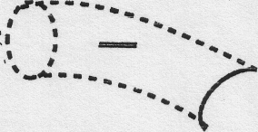
Figure 2
The experience of rewinding the tape (5.2b) is not actually recorded or ‘contained’ on any camera nor does it contain another experience that is recorded on a video camera. However, it is part of the continuum of the experience. So we provide a position in-between the first position and the next position for the passage of time in which the experience of rewind takes place. (- =).
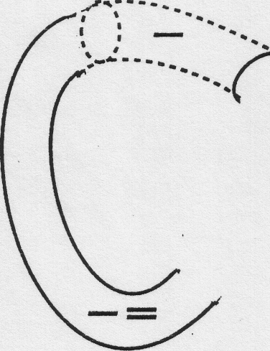
Figure 3
The second recording (5.2c) contained the first recording so we slip the one continuous tube around the position of firstness and thereby create a position of secondness (=).
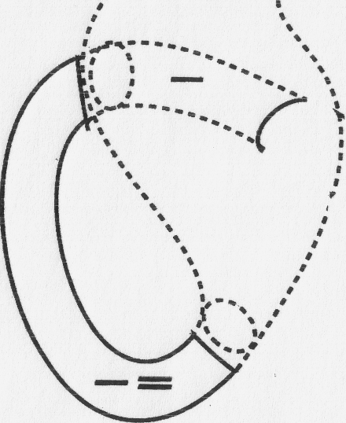
Figure 4

Again the rewinding and exchange of tape (5.2d) is neither contained nor containing so provide an interval in the continuum for that part of the whole experience (= =).
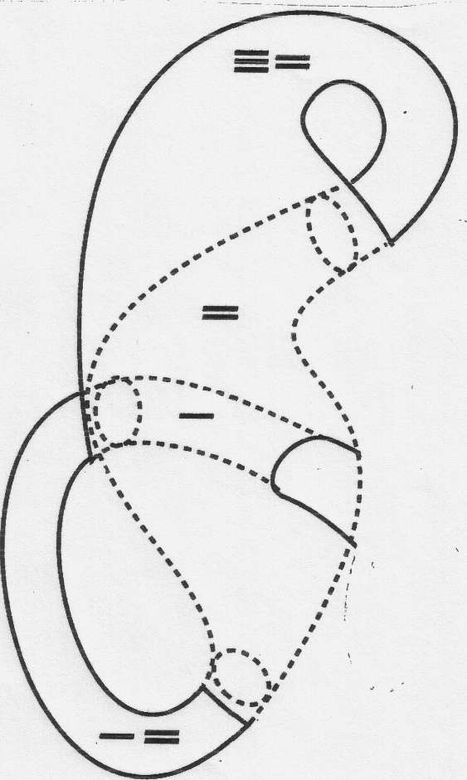
Figure 5

Now in the third recording (5.2e), to map when you watch your reaction to the spontaneous first recording, slip the continuous tube over the first position and the second position in the tube to create a third position that contains the first and the second position (=)

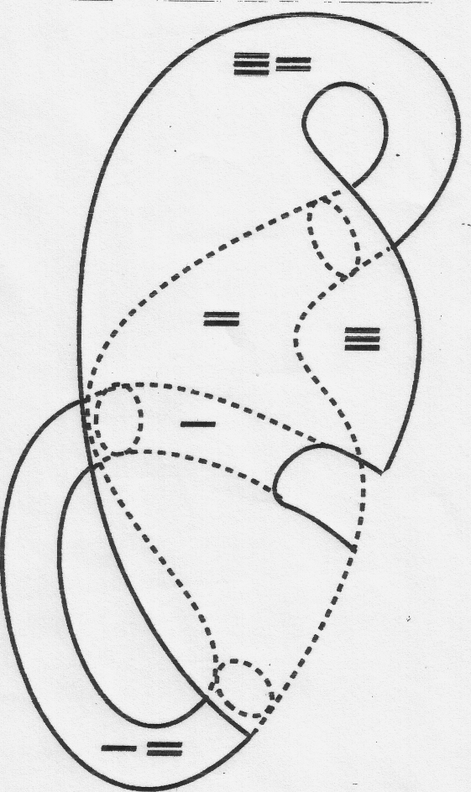
Figure 6
When you rewind and reset (5.2f) the machines for another spontaneous recording, you are creating another part neither contained nor containing that is an interval between the mediation in the third position and the spontaneity of the first position (= -).
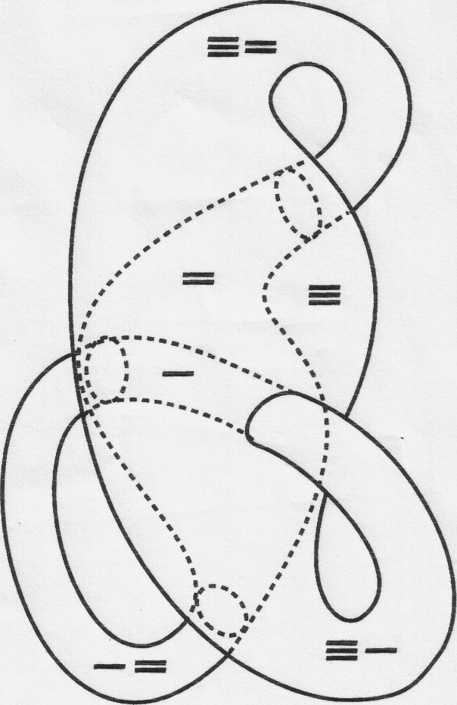
Figure 7: The Relational Circuit (a six-part closed Kleinform) with its six unambiguous positions labeled. There is a position of firstness (-), a position of secondness (=), and a position of thirdness. In addition, there are three in-between positions;
Of course one can continue the process of doing feedback upon your own feedback ad infinitum. In one of my early tapes, Media Primer, I took this process to seven levels of feedback. From these seven levels of feedback, you could abstract a circuit with seven parts contained and containing along with the appropriate parts uncontained. My choice to close the circuit with three parts contained and containing is based on two considerations. One, I wanted to keep the circuit at no more than six parts. Since six is perceptible without counting, the human mind could use the circuit to differentiate without naming, numbering and classifying parts. Two, I was convinced by reading Peirce that in a logic of relationships there is no fourthness as such. For example, the seventh feedback level can be understood as containing the fourth, fifth and sixth level, which in turn contains the first, second and third. Three parts contained and containing provide a fecund minimum from which its is possible to build any combination of relationships. So to create the relational circuit I stopped the process of abstracting from video recording of video recording to a total of six parts contained, containing and uncontained. These six parts give you a compete circuit.

REFERENCES
Abbott, Edwin A. 1952. Flatland. New York: Dover.
Bateson, Gregory. 1979. Mind and Nature. New York: Dutton.
——— 1972. Steps to an Ecology of Mind. New York. Ballantine
Brown, G. Spencer 1972. Laws of Form. New York: The Julian Press.
Deleuze, Gilles 1986. Cinema 1. Minneapolis, University of Minnesota.
Lambert, Greg 2002. The Non-Philosophy of Gilles Deleuze. NYC: Continuum.
Luhmann, Niklas 1998. The Ecology of ignorance. In Observations on Modernity. pp. 75-112. Stanford Ca., Stanford University Press
McCulloch, Warren 1965. A Heterarchy of Values Determined by the Topology of Nervous Nets. In Embodiments of Mind. pp. 40-45. Cambridge, MA: M.l.T. Press.
McLuhan, Marshall 1962 . Gutenberg Galaxy. Toronto: University of Toronto Press.
——— 1964. Understanding Media. New York: McGraw Hill.
Murphey, Murray 1961. The Development of Peirce's Philosophy. Cambridge, MA: Harvard University Press.
Peirce, Charles S. 1998. The Essential Peirce vol. 2. Ed. Edition Project. Bloomington and Indiana: Indiana University Press..
——— 1955. Peirce, Charles S. The Principles of Phenomenology. In Philosophical Writings of Peirce. Buckler, J. (ed.) pp. 74-97. NYC: Dover Press.
——— 1931-35. Collected Papers. eds. .C. Harthshorne and P. Weiss vols. I-VI. Cambridge, MA: Harvard University Press
Ryan, Paul 2002. Gender and Threeing. In Semiotica 138 1.4, 371-392. New York: Mouton de Gruyter.
——— 2001. www.earthscore.org (See site map)
——— 1998 Peirce and Work. In New Approaches to Semiotics and the Human Sciences eds.. W. Pencak, and J. R.Lindgren.. pp. 95 -126. NYC: Peter Lang.
——— 1996. Video Wake for My Father. In Fire Water Father (with James Ryan, limited edition) NYC: Earth Environmental Group.
——— 1993. Video Mind, Earth Mind: Art, Communications and Ecology. NYC: Peter Lang.
——— 1991. “A Sign of itself.” In On Semiotic Modeling. eds. Myrdene Anderson and Floyd Merrell pp. 509-524. NYC: Mouton de Gruyter.
——— 1985. A Ritual of Triadic Relationships, NYC: Electronic Arts Intermix (videotape).
——— 1980. Metalogue: Gregory Bateson, Paul Ryan. All Area Vol. 1, #1.
——— 1976. Video Variations on Holy Week (One-Person Show) NYC: The Kitchen.
——— 1974 Cybernetics of the Sacred. NYC: Doubleday.
——— 1971. Attempting a Calculus of Intention, part two of Cybernetic Guerrilla Warfare. See diagrams labeled ‘Klein Worms’ (http://www.radicalsoftware.org/volume1nr3/pdf/VOLUME1NR3_art01.pdf)
Stewart, Ian. 1998. Glass Klein Bottles. In Scientific American, March 1998.

